**Software upgrade instructions**

**1 Hardware connection showing as below:**

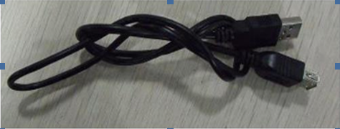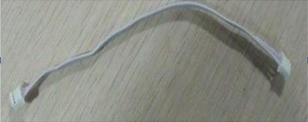

USB cable4-Pin Reverse Wire

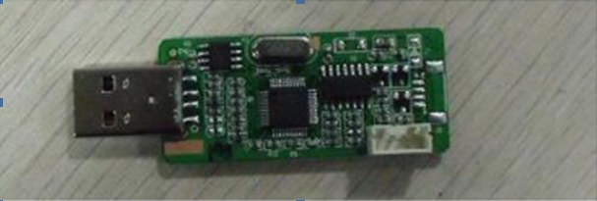

Debug board

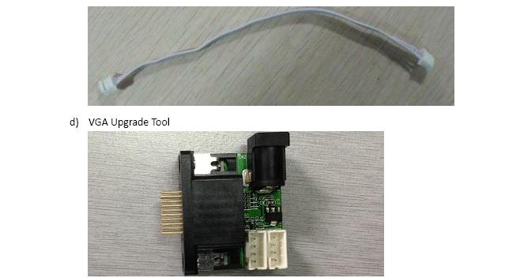OR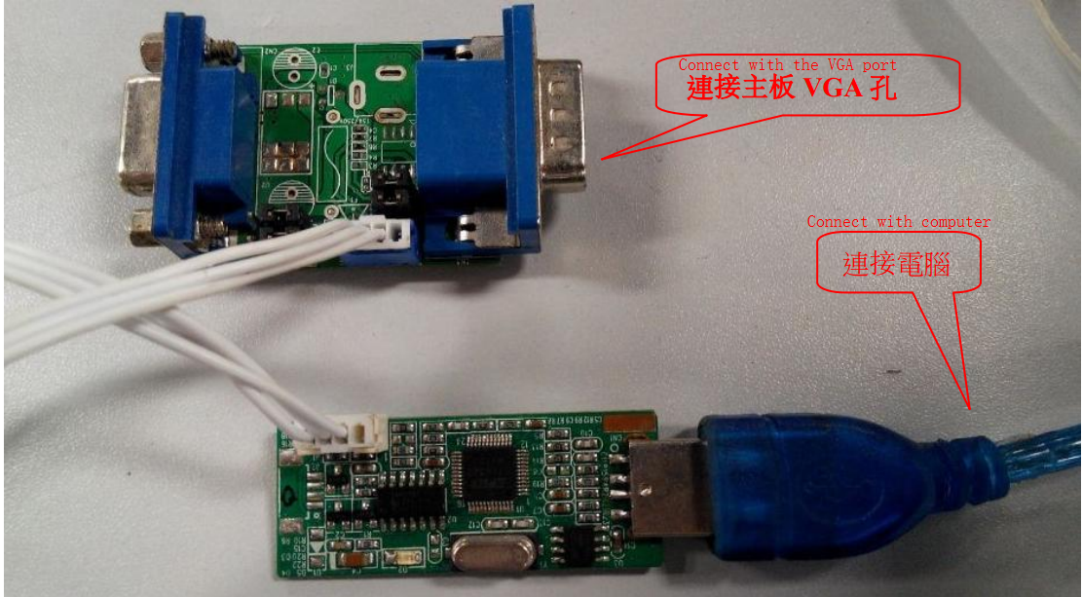

VGA connecter

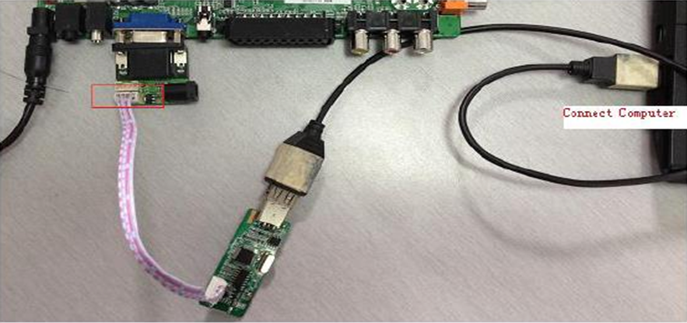

Over View of the connection

**2 Software Tools Over View:**

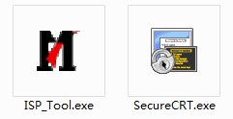 

**3 To Load Mboot:**

3-1,Run the ISP_Tool.exe in the DRIVERS folder.



3-2,Check the configuration in the Config page:

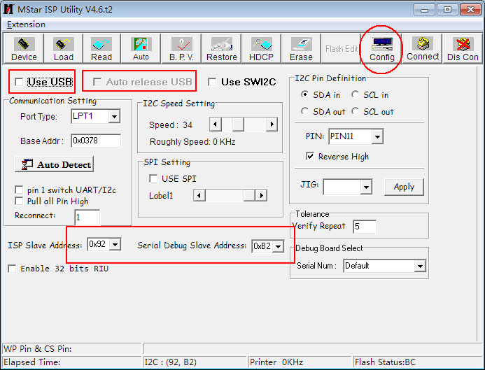

1. The Use USB && Auto release USB box should be selected with hook
2. The ISP Slave Address should be 0x92 and the Serial Debug Slave Address should 0xB2

3-3,Select chip type in Auto page:

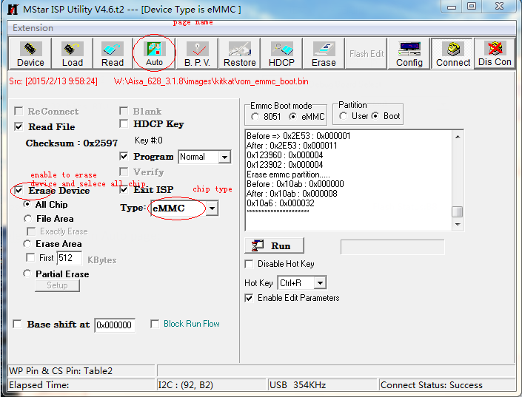

a,chip type select eMMC

b,enable the Erase Device option and select All Chip

3-4,Load bin files in Read page:

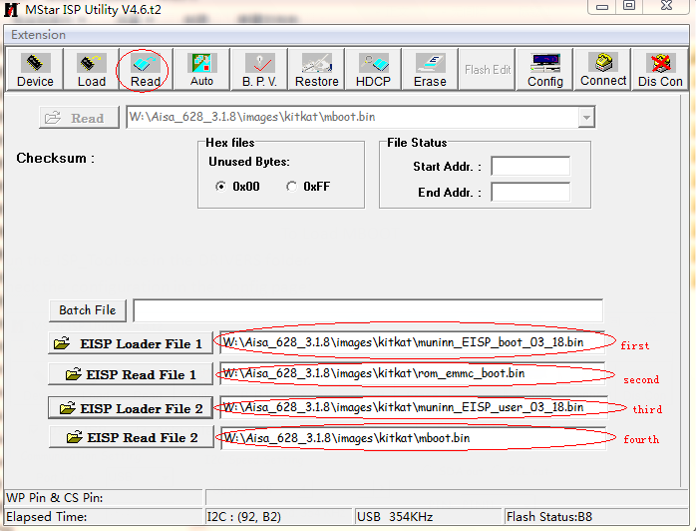

Please notice the sequence of the four files in names.

3-5,Go to Auto page to do the mboot loading.

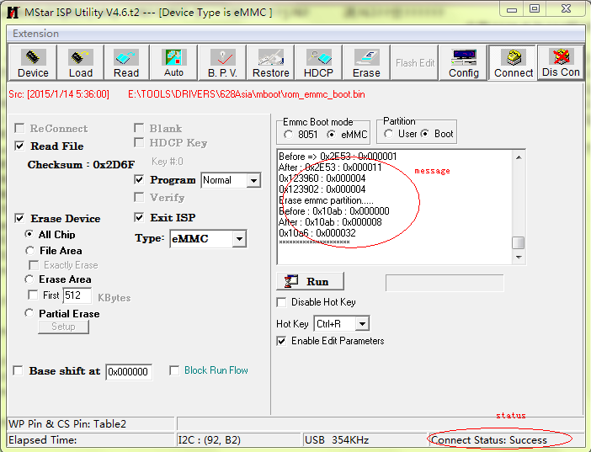

Click the Connect button to connect the tool with the board. Notice the message that whether there is any errors showing. When the Connect Status in right bottom showing Success, user can start the sw loading by press the Run button.

Note: If fail to connect after trying many times, please do main switch off of TV and then take a try again.

3-6, If everything goes well, after two times loading process there will be a green Pass display on right side of the Run button.

3-7,After the mboot loading do main switch off/on of the TV with the SecureCRT connected & worked (Please take a reference about the document about the SecureCRT), it will go commend line with “<<Mstar>>#”

When it display commend line with “<<Mstar>>#” the mboot loading is finished successfully. Next is to do main s/w updateing.

1,Put the MstarUpgrade.bin file in the root of a USB device,

2,Connect the USB device with the USB port of the board (better connect with the USB1 port, as the board will scan for the s/w bin file from USB1 to USB2)

3,Input custar in the commend line then press Enter key to enter the updating process.

Note: Please notice that do not disconnect the power supply during the updating process, or you have to do all above once again.

**4 To Config SecureCRT.exe:**

4-1,Run SecureCRT.exe



4-2,Config in the coming out dialog window:

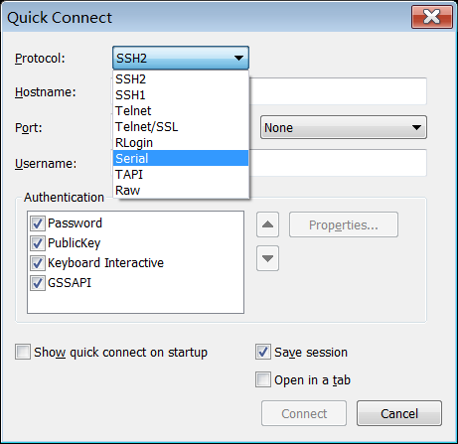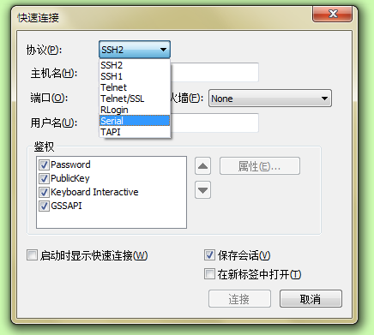

Select Serial in first item

4-3,with selecting Serial in the dialog window showing in the first step, the window will change into new form:

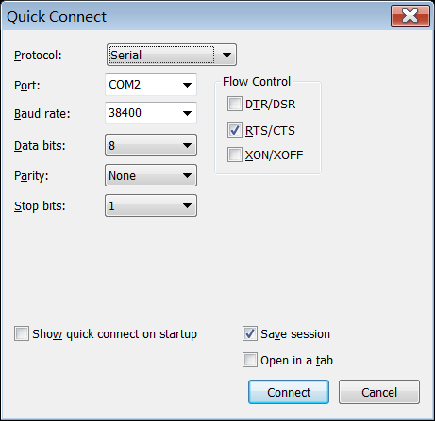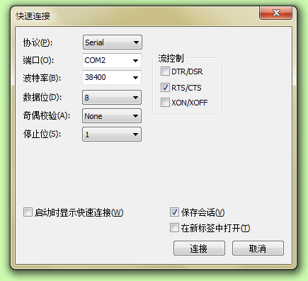

A, Select proper COM port for your computer (Mine is COM6, you can find the details from the device manager of your PC )

B, Config other items same as showing in below:

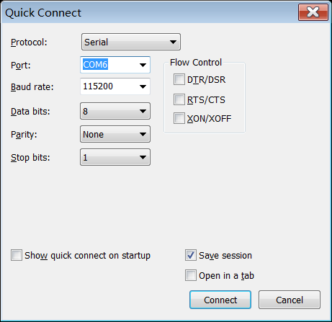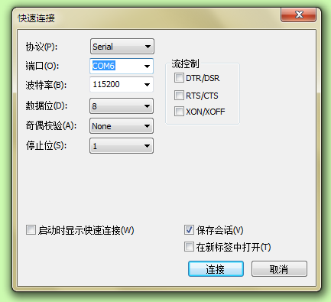

C, Select the Connect button (showing in green color in the picture above).

**5 To Upgrade S/W:**

5-1, After the success of the step 5-3 with the SecureCRT working and then mainly switch off &on the TV or just a board. The display in the SecureCRT window will go into <<Mstar>># in the end.

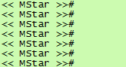

In such condition, if you press Enter key of the computer there will keep displaying <<Mstar>>#in the new line

5-2, Put the s/w bin file (with the name: MstarUpgrade.bin) in the root folder of a USB device. Connect the USB device with the USB2.0 port of the TV or board. Please notice that the USB port with Blue color is the USB3.0 port which is no used in s/w upgrading.

5-3, Input custar in SecureCRT window and press Enter, showing as below:

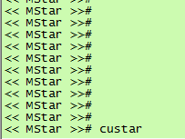

Waiting for about 3 minutes till the upgrading process finish, then power on the TV or board by Remote or Front key board power key.